A2 COMPUTING PROJECT (F454) DOCUMENTATION

SAM’S SANDWICHES

Contents Page

Definition, Investigation and Analysis 2
Project definition 2
Investigation and analysis 3
Requirements specification 8
End user feedback 10
Design (16 marks) 11
Nature of the solution (6 marks) 11
Algorithm design and testing (5 marks) 11
Batch test planning (5 marks) 11
Software development and testing (30 marks) 13
Development (16 marks) 13
Testing (14 marks) 13
Documentation (10 marks) 14
Technical documentation 14
Evidence of on-line help 14
Evaluation (10 marks) 15

SAM’S SANDWICHES

Definition, Investigation and Analysis

Project definition

Description of the organisation

Sam’s Sandwiches is a small business run on a part-time basis by Mrs A Lee from her home in Kings Norton. She makes up lunch-time sandwiches for a number of local businesses who form her customer base. The materials for the sandwiches (bread products, fillings, butter, Clingfilm) are bought by Mrs Lee from a local cash and carry outlet every other day. She works on her own to fulfil the orders and wraps them for delivery or pick-up. Approximately 20 local businesses form her main customer base and a typical daily order by one customer would be for 10 products. Mrs Lee’s order processing system is currently entirely paper-based, which is causing problems as the business expands.

Description of how the chosen problem is dealt with at the moment.

Mrs Lee takes phone calls and emails from local businesses who give their orders for the sandwiches they want her to make for that day. The details of the orders are written down on a notepad and are kept in the kitchen to refer to. She then makes up the sandwiches which are then picked up by the customer or delivered by her husband. Part of the order processing is recording if orders are to be collected or not. A hand written invoice is included with the sandwich order and the customers pay with cash on pickup/delivery.

Mrs Lee guesses the amount of ingredients she will need when buying them, and sometimes runs out, or waste ingredients by buying too much. From the ingredients she makes a variety of sandwiches and rolls, with a mixture of bread types and fillings. These options form her ‘menu’.

Description of the data that is used in the area of the problem.

Mrs Lee uses the following information:

- Customer names, addresses, telephone numbers, email addresses.
- Lists of ingredients
- Lists of products, e.g. sliced bread, rolls, baguettes, cobs, various fillings
- Cost of products, e.g. brown roll, with cheese and tomato filling, £1.20

Where the data comes from

Mrs Lee makes up a menu of products based on her experience. Customers can choose products from this paper menu which is sent to local businesses, or she will read out the options over the phone. She does not create ‘custom’ products, but new items will be added if requested often (or old items removed if unpopular).

Customer details are kept in a notebook. Invoices, showing customer name and address, items chosen, quantities and total cost, are hand written. The total from each invoice is added to a second notebook, which is totalled each week to see total income for the week. Receipts for ingredients purchased are usually kept in a plastic wallet, and are sometimes totalled to check outgoings. Most payments are in cash, but sometimes cheques are taken which Mr Lee banks each week.

Mrs Lee is interested in using a computerised order processing system. In order to see how this might work, a full investigation and analysis will now be carried out.

Investigation and analysis

Fact finding

In order to find out in detail how the current system works and what problems are being encountered, the following fact finding plan has been created:

- Carry out initial interview with Mrs Lee – 18/09/09 - record findings
- Analyse existing documents and data – e.g. invoices
- Observe order processing taking place over a one hour period
- Draw DFDs of current system
- Carry out a further interview with Mrs Lee - 25/09/09 - to discuss outcomes of fact finding

Initial interview – transcript of key points

Question | Response
Can you explain what happens when you take an order? | If a customer rings through, I take their name and write it on a new sheet of paper in the order notebook, then I start to write down their order as a list.
What exactly do you write down? | The sandwich types they want, how many of each, whether the order is to be delivered or picked up, and what time they want it. I then quickly add up the bill and tell them the total.
Do you use a calculator to do the last bit? | No, I do it by hand, but sometimes I make mistakes.
Do you have an old order I can look at? | Mrs Lee supplied an old order – see below.
What do you do next? | I use the order as a list to work from, so I can make up the sandwiches later on.
Does that work OK? | It’s a bit time consuming to keep writing orders down, and I sometimes have to take orders half way through making up an order for someone else.
Do you take orders in any other way? | Some companies email their orders through – they have to reach me by 10.00am. I can print the email, but I usually just read it from the screen.
So you have a computer in your kitchen? | Yes, a laptop, with Windows 7 and MS Office.
How do you create an invoice? | On a separate piece of paper, I write the company or customer name again, and the total bill, plus the total number of sandwiches or buns in the order. This goes with the actual sandwiches in a paper bag. If the order is to be delivered, my husband is responsible for knowing where orders must go.
So you don’t write the quantities of each individual order line on the invoice. | No, I don’t really have time, but this does sometimes cause problems as the customer can’t see their original order. Sometimes they say I haven’t done the order properly.
What specific problems have you been having with order processing? | As well as some arguments with customers, I sometimes have trouble finding time to take orders and make sandwiches at the same time. It takes time writing down all the details.
Do you find you have to repeat data often? | Yes, I feel like I keep writing down the same things lots of time. I use my own shorthand to some extent, but it is still time consuming. Now and again I can’t read my own writing properly, which can cause trouble. I also find I can get orders mixed up when I have to take a lot at once, and I sometimes forget to write if the order is to be picked up or delivered. Do you think that a computerised system would overcome these problems?
Possibly, it is certainly worth looking at further. How much experience do you have with computers? | I use a laptop for emails and on-line shopping, so you could say I’m quite comfortable with using a computer. I have also used spreadsheets and a word processor, and I have a CLAIT level 2 qualification.
Thank you for your time. I’d like to analyse this information and interview you again on the 25/09/09. | That’s fine, thank you.
It is now possible to draw a DFD (level 1) of the order processing system as it stands.

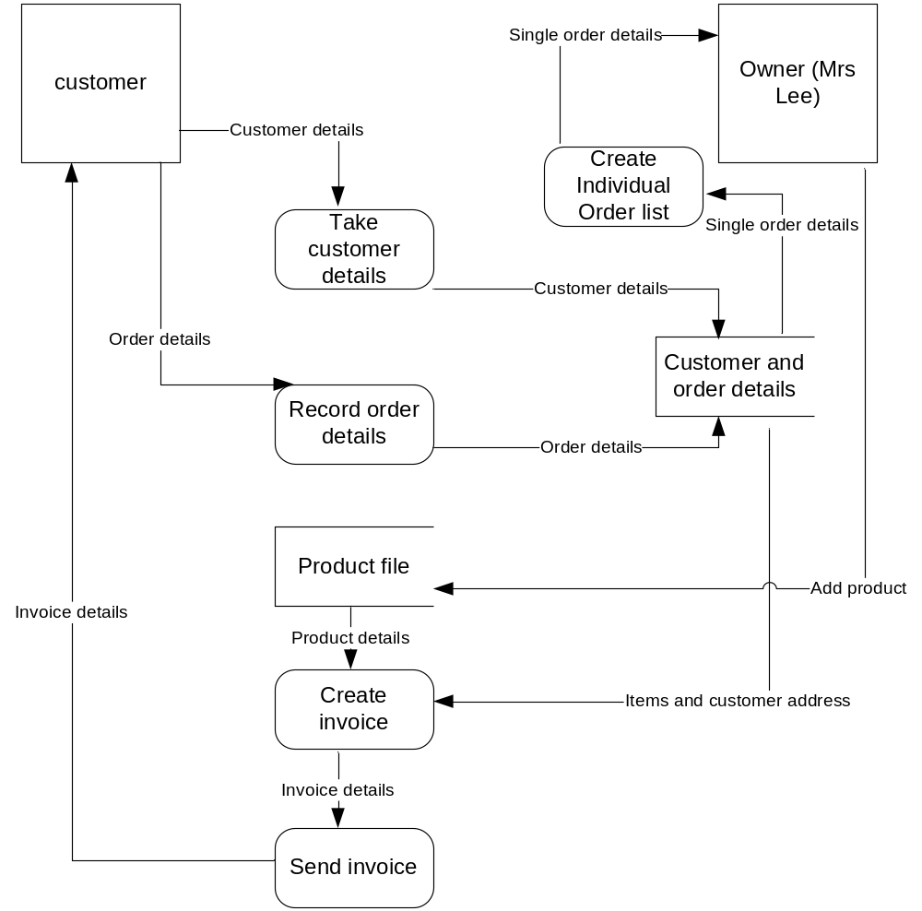

The diagram shows that the current system has two key inputs, one data store, and two key outputs. A computerised system would have to be able to accept and store customer details and details of their orders, and produce both an invoice and a list of the details of individual orders, to help Mrs Lee make them up.

There is considerable duplication in the paper based system, as customer details are recorded every time there is an order, and products are jotted down for every order. Below are examples of an order and an invoice.

Sample invoice

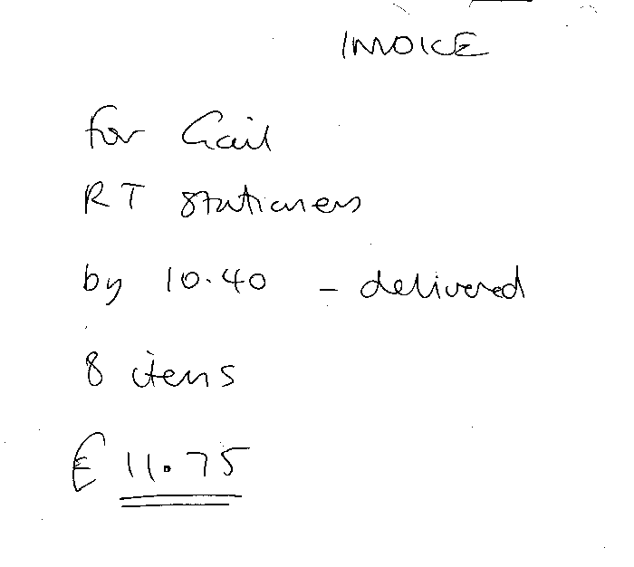
Sample order

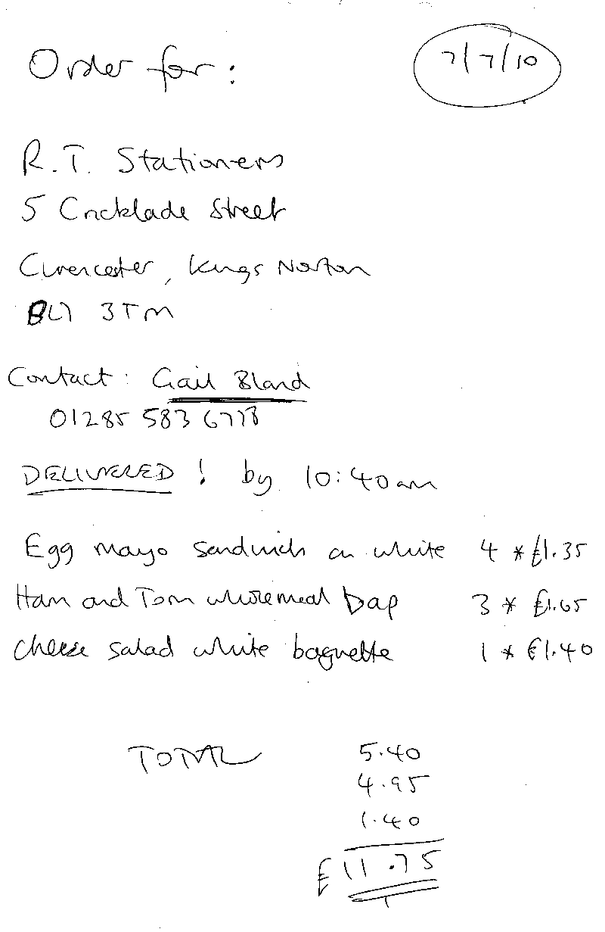
All delivered orders include a fixed delivery charge of £2.50.

From the gathered information it is possible to list attributes from the data storage:

- Company name
- Customer name/contact name
- Company address (several attributes)
- Company telephone number (of contact)
- Company/contact email address
- Time order wanted (always same day?)
- Whether it is to be picked up
- Product type (e.g. baguette, sandwich, cob)
- Bread – white, brown, wholemeal
- Fillings for product
- Quantity required (noted when order taken, but not on invoice)
- Product cost
- Total cost
- Total number of items (on invoice)
Analysis of the required system

To begin analysing the required system, a few further questions were asked of Mrs Lee (by email).

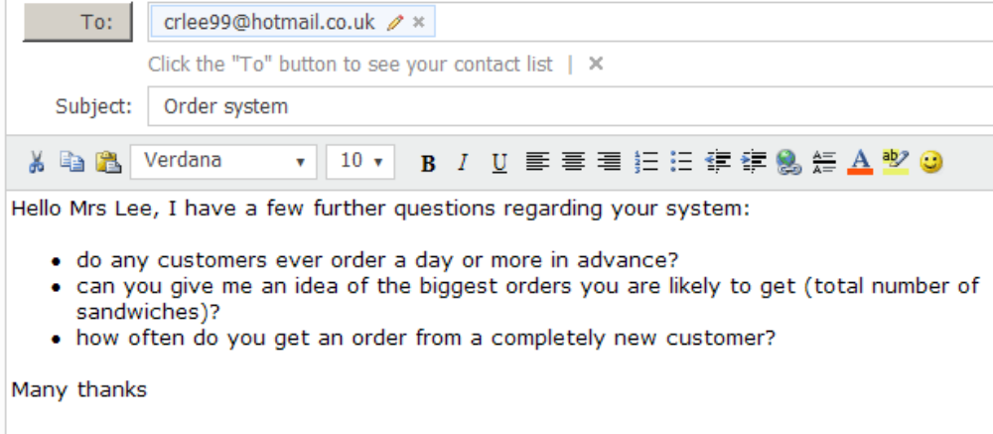

Here are the replies from Mrs Lee.

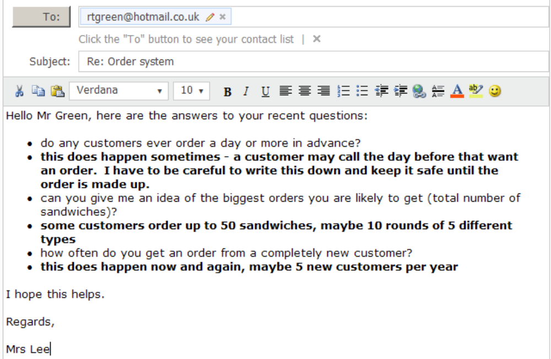

So now I can see that Mrs Lee needs an order processing system which will store customer names, allowing new ones to be easily added and existing ones edited if necessary. She needs to be able to create a new order for a customer by adding order lines consisting of a product type, bread type, filling, quantity and cost. The data and time for collection/delivery needs to be stored, along with whether the order is to be delivered or picked up. The total order cost must be calculated. I will need to ask if there is a delivery cost to be added.

To reduce duplication, customer details can be stored once but then linked to an order. Product types can also be stored once, along with fillings and prices (need to ask how often prices change).

Mrs Lee must be able to create an order easily in her kitchen, using her laptop, then be able to print an invoice.

Second interview

A second interview was held on the 25/09/10 to discuss requirements of the new system.

Question/Answer | Response/Question
Can you tell me if there are delivery costs for orders which are to be delivered? | Yes, I charge a flat rate of £2.50 for delivery.
And how often are you likely to change product prices? | I only do this if I notice that the ‘raw materials’ have gone up e.g. if bread becomes more expensive. I probably do this once a year on average.
Do you think it would be possible for you to use a mouse to create orders on your laptop as you take them on the phone? | Yes, I think so. If I could just click on items on a list to make the order that should be OK. Could I also select customers like that?
Yes, certainly, you could have a customer list. New customers would need to be added manually, of course. Can you give me a list of existing customers? | Yes, I’ll type that up for you. And a list of all the products I make and possible filling combinations.
Do you ever make custom fillings, or can customers select only from a menu? | I don’t normally do custom fillings. If a customer is persuasive, I sometimes add a new type of sandwich just for them. I do this so that I can have a set price list which I word process and send out to customers.
What about printing invoices, do you have a printer for your laptop, and could it be placed in the kitchen? | I like the idea of having the invoices printed, as it would look more professional. I’m not sure about having the printer in the kitchen, though. It might get damaged. Also, could we get some protection for the laptop against spills? I may need to have it on the work surface if I use it for orders.
Good point, maybe a wireless printer in another room would be better. I’ll look into this, and a cover for the laptop, or maybe a separate keyboard and mouse. Would I be able to see the laptop and jot down what software you are currently using? | Yes, no problem. I’d prefer not have to buy any extra software.
If we go with a computerised solution, is there any other report, paper or screen, which might help you? | Would it be possible to view past and existing orders? Also, could the system give me an overall total of all orders to date?
Yes, that should be possible. Anything else? | A list of orders for the next day might be useful. And could I print a menu, based on the fillings I enter?
I think printing a menu is a great idea, and orders for the following day should be possible. I’m thinking that a wireless inkjet printer would be the best option for printing.  I’ll write up a list of requirements and objects, and go through them with you next week. When we are all agreed, I can start to design the system. | If you are recommending a wireless inkjet printer, can I also add that I would like a scanning facility built in.  OK, many thanks.
One last question, I assume you have Internet access in the house as you receive emails. Do you have a router and wireless network? | Yes, we have a BT HomeHub.

Based on this extra information, the required system DFD can now be drawn up.

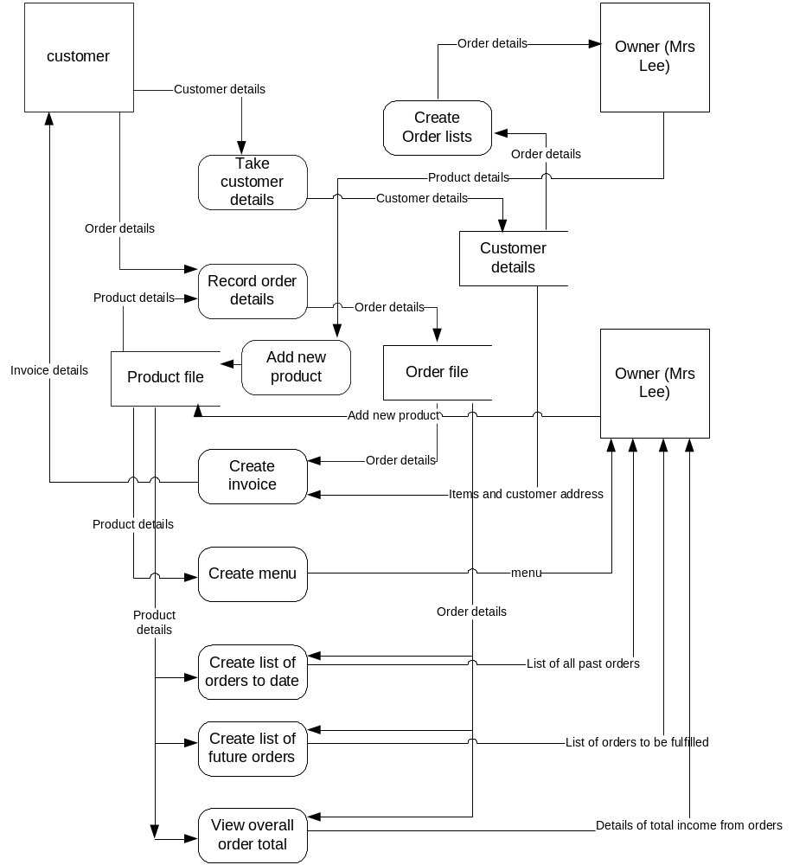
Input, output, process storage

From the level 1 DFD it can be seen that the following components exist:

- Inputs
  - Order details
  - Customer details
  - Product details
- Outputs
  - Menu of current products
  - Invoice
  - Order details
  - All past orders
  - All future orders
  - Total income from orders
- Processes
  - Enter/edit customer details
  - Enter/edit product details
  - Enter order
  - Create invoice
  - Create list of orders for day
  - Create view of past orders
  - Create view of future orders
  - View grand total of all past orders
  - Create menu
- Storage
  - Customer file
  - Product file
  - Order file

Requirements specification

From the interviews, emails and document analysis, it is now possible to create a list of requirements which the new system would need to fulfil:

- Store customer details, including contact details
- Add new customers
- Add new products (filling, product type, bread type, price)
- Edit product prices
- Add a new order for a customer
- Add order-lines on the order, including quantities required up to 50
- Calculate each order-line total
- Calculate the order total
- Produce a printed order
- Produce a printed invoice showing the order-lines and order total, and whether the items are to be delivered or picked up (along with date/time needed)
- Produce a printed menu of all available products
- View past and existing orders on screen
- Produce an on-screen overall total of all orders to date
- Produce an on-screen list of orders for the next day

Hardware specification

The key hardware requirements are for a Windows platform laptop and a printer for hard copy. The laptop will need to be useable in a kitchen environment, while the printer will need to be placed outside the kitchen and connected wirelessly. The recommended product is a HP DeskJet Wifi F4580 Wireless All in One Printer, which is currently available for £45. This printer:

- Will allow Mrs Lee to print from her laptop via her existing wireless network
- Will print in colour when creating menus, at a resolution up to 1200 dpi
- Will print at up to 22ppm, which will easily keep up with the requirements.
- Uses easily obtainable ink cartridges
- Allows Mrs Lee to scan images
- Works with Mrs Lee’s current operating system, Windows 7.
- Has a one year warranty.

The full specification is given below.

Automatic Document Feeder No
Borderless Printing Yes
Brand HP
Built in Card Reader None
Built in LCD Screen No
CD DVD Printing Tray No
Colour of Case Black
Compatible Black Cartridge HP 300 / HP 300XL
Compatible Cmy Cartridge HP 300 / HP 300XL
Copying Facility Yes
Direct Printing From Memory Card Yes
Direct USB Printing Yes
Fax No
Fax Page Memory No
Features of Product Built in wireless 802.11g. Print and copy up to 28ppm black, 22ppm colour. 1200 x 2400 dpi scan resolution. Dual drop weight technology. HP smart web printing. Ink level indicators
Firewire Connection No
Horizontal Scanning Resolution DPI 1200
Linux Supported No
Mac Os X Supported Yes
Maximum Print Size A4
Maximum Resolution Horizontal DPI 4800
Maximum Resolution Vertical DPI 1200
No of Ink Cartridges 2
Pages Per Minute - Colour 22
Pages Per Minute - Mono 28
Paper Tray Capacity 100
Pictbridge Compatible No
Printer Type Colour Inkjet - All in One
Product Depth 29.1 cm
Product Height 16.2 cm
Product Weight 4.9
Product Weight Units kg
Product Width 43.8 cm
Scan Yes
Scsi Connection No
USB 2 Connection Yes
USB Connection USB 2.0
Vertical Scanning Resolution DPI 2400
Windows 7 Supported Yes
Windows 98 Me Supported No
Windows Vista 32bit Supported Yes
Windows Vista 64bit Supported Yes
Windows Xp 32bit Supported Yes
Windows Xp 64bit Supported Yes
Wireless G Connection Yes
Wireless N Connection Yes

Mrs Lee’s laptop will act as the main platform, and already has Windows 7 and MS Office installed. A driver for the wireless printer is included with the printer. An Internet connection also currently exists for sending and receiving emails (including occasional email orders), and a wireless router and network is in place.

The main issue is that the laptop will be used in a kitchen environment, which does cause some concern. For that reason, a laptop keyboard protector cover skin is recommended, costing approximately £2.00. www.topsellings.com sell a cover with this specification:

Made with durable silicone, soft and comfortable
Super slim, high transparent, easy to recognize all keys
High elasticity, nice tactility
Waterproof, dustproof and durable
Non-slip design, you can type and play games normally
Easy to install, just place it on the keyboard directly
Adhere to keyboard closely, not affect keyboard use
Flexible, convenient to store

Software specification

As well as Windows 7 and a driver for the printer, the other software which will be needed is for creating the solution. From the data gathered so far, the options look to be:

1. A Visual Basic 2008 programmed solution using binary files to store the customer data, order data and product data. This software will allow a user interface to be created, and formatted reports can be sent to the printer. The 2008 version requires the .net 3.5 or higher framework, which is included as part of Windows 7. This solution would require no other software to be installed.

2. A VB 2008 programmed solution, but using Access tables to handle the data storage. This has the advantage of not having to programmatically control the links between related files, as this is carried out by the software when the links are created. Mrs Lee’s laptop has Access 2007 already installed.

3. A web-based solution using php for processing and mySQL for data storage. This solution requires server software to be installed, along with php and mySQL.

4. A spreadsheet solution, where data is stored in a dedicated workbook and processing is via formula and VBA. Print options are available by setting up worksheets as reports. Mrs Lee’s laptop has Access 2007 already installed.

The recommended solution is option 2, as this includes all the necessary file storage options, as well as providing the programming facilities and output options. Access will easily cope with the expected storage requirements. It requires no extra software to be purchased or installed by Mrs Lee.

Option 1 is similar to option 2, but requires the data files to be created and linked programmatically, which has significant maintenance issues in the future if changes need to be made to the file structures. Option 3 requires considerable installation and configuration work, and may create compatibility issues with other software, and present security problems. It may also require greater software maintenance in the future.

Option 4 may not be fully suitable because spreadsheet packages do not include automatic facilities for implementing relation data models, which appears to be required in this case.

Objectives

From the user requirements it is possible to determine measurable objectives which can be tested when the program is operational

- Enable an order to be taken on-line during a phone call by selecting items with a mouse
- Enable an invoice to be printed within 60 seconds
- Enable a full colour A4 menu to be printed
- Enable existing orders to be viewed and printed within 60 seconds
- Allow a new product to be entered with two minutes
- Allow a new customer to be entered within two minutes

Mrs Lee will be given the opportunity to look over these requirements and objectives and feed back.

End user feedback

Below is a copy of the feedback from Mrs Lee. In it she states that she is happy with the requirements list and objectives, the intended solution, and the purchase of hardware. I can now start he design process.

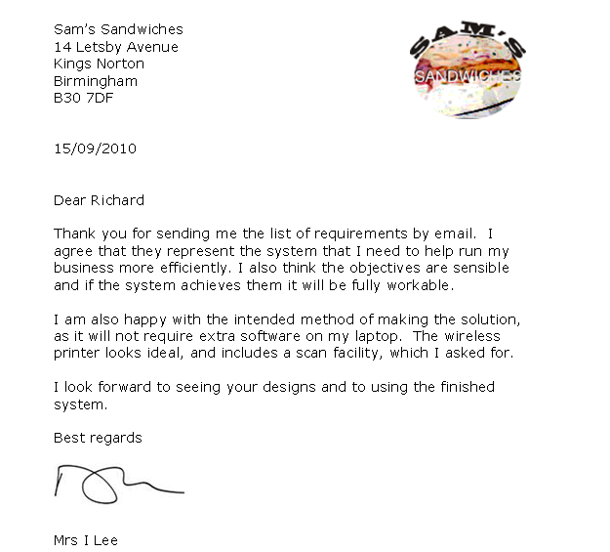
Design

A detailed systems design (including appropriate diagrams) should be produced and agreed with the users. Proposed record, file and data structures should be described and design limitations should be included. Design of data capture forms, input formats (with examples of screen layouts) and output formats should be included. A detailed summary of the aims and objectives should also be included. These items are the design specifications, which should be agreed with the user.

Nature of the solution (6 marks)

A clear set of objectives with a detailed and complete design specification, which is logically correct. There is evidence to show that the end user has seen and agreed these designs. There are also detailed written descriptions of any processes/modules and a clear, complete definition of any data structures. The specification is sufficient for someone to pick up and develop an end result using the software and hardware specified in the requirements specification.

Input design (including on-line help)

Output design

Process design (refer to algorithms)

Data structures

Objectives and design limitations

Objectives should be measurable

End user feedback

Algorithm design and testing (5 marks)

Detailed language-independent algorithms should be developed together with evidence that the algorithms have been tested to ensure they meet the design objectives. For 5 marks, a complete set of algorithms with evidence to show that they have been assessed by the candidate to show that they will meet the design specification. (Evidence should show how these algorithms form a complete solution and that they have been tested for functionality using appropriate techniques.)

Design of algorithms (pseudocode/flowcharts/structure diagrams)

Dry running to test algorithms

Batch test planning (5 marks)

A detailed test strategy and plan, together with appropriate test data, should be developed and documented. It is vital to produce test cases and to show that they work. To do this, it is necessary not only to have test data, but to know what the expected results are with that data.
For 5 marks, a detailed test strategy and plan covering all aspects of the system with data to test under normal, extreme and abnormal circumstances.

Test number | Purpose of test | Input data to be used | Expected result
A test plan should also be created for the users, specifying the purpose of each test and the data to be used. The results will be review during the next section.

Software development and testing (30 marks)

Development (16 marks)

A technical description of how the solution relates to the design specification produced and agreed with the user should be included. It is the responsibility of the candidate to produce evidence of their development work. This section must show how the candidate tested each section during development and the responses to this alpha testing. The code must be documented adequately to explain its function and there must be clear evidence of how modular code has been used to develop the final solution.

Code listing (with comments)

User feedback

Further evidence of development (include anything not shown as a screen shot during batch testing)

Testing (14 marks)

An attempt should be made to show that all parts of the system have been tested, including those sections dealing with unexpected or invalid data as well as extreme cases. Showing that many other cases of test data are likely to work – by including the outputs that they produce – is another important feature. Evidence of testing is essential. The beta testing should cover all aspects of the test plan produced in the design section, which should cover all aspects of the design specification. The examiner must be left in no doubt that the system actually works in the target environment. This evidence may be in the form of hardcopy output (possibly including screen dumps), photographs or any format that does not require access to any specific hardware or software. The end user(s) must be involved in this process and evidence of end-user testing is required.

Batch test results (include objective testing)

Complete the table from the previous section:

Test number | Purpose of test | Input data to be used | Expected result | ACTUAL RESULT | COMMENTS
 |  |  |  | Screen shots

Evidence from user testing

Feedback on user testing, as designed in the previous section.

Documentation (10 marks)

Quality of Written Communication is assessed in this documentation. Much of the technical documentation will have been produced as a by-product of design and development work and also as part of writing up the report to date. The software solution should also include sufficient on-screen help to enable the end user to make use of the system. Some additional supporting documents will be necessary including initial set-up, getting started and troubleshooting guides, to ensure the end user can implement the solution.

Technical documentation

Refer to the previous documentation where necessary, and add any new work needed to explain technical aspects of your system.

Evidence of on-line help

User guide (introduction, how to install, how to run and use, troubleshooting, contact details)

Best as a standalone document – don’t forget to show evidence of the available on-line help.

Evaluation (10 marks)

Success in meeting original objectives (4 marks)

This discussion should demonstrate the candidate’s ability to evaluate the effectiveness of the completed system. The original objectives stated in the requirements specification should be matched to the achievements, taking into account the limitations. User evaluation is also essential and should arise from direct user evaluation.
For 3–4 marks a full discussion, taking each objective mentioned in (b) (i) and explaining the degree of success in meeting them (indicating where in the project evidence can be found to support this), or reasons why they were not met.

Evaluation of the user’s response to the system (3 marks)

It is important that the user is not assumed to be an expert in computer jargon, so some effort must be made to ensure that the system is user-friendly. It will be assumed that the user will have considerable knowledge of the underlying theory of the business or area being computerised. Clarity of menus, clear on-screen help and easy methods of inputting data are all examples of how the system can be made user-friendly. Here marks are awarded for the degree of satisfaction that the user indicates in the acceptance procedure. Could the system or its results be used? Was the system specification achieved? Do any system faults still exist? The candidate should evaluate the user’s response to the final version of the system.

Response (may be in the form of letter or emails)

Comments on user response

Desirable extensions (3 marks)

As a result of completing the system, the candidate should identify the good and bad points of the final system, highlighting any limitations and necessary extensions to the system, and indicating how the extensions could be carried out.
For 3 marks a clear portrayal of the good and bad points of the system indicating the limitations, possible extensions and how to carry out the extensions.

Good points

Bad points

Extensions and how to carry them out

